**SOFTWARE PROJECT MANAGEMENT LAB 3**

SUNIL TUMKUR 100620430

Eric Tsim 100560172

Harshwardhan Goswami 100654736

TEAM NAME: OW

1. **Estimated Effort**

Basic Model for Effort Measured in Person-Months:

E = a(KLOC)^b

Organic: a=2.4, b=1.05

Semi-Detached: a=3.0, b=1.12

Embedded: a=3.6, b=1.20

Assumptions:

-The iPas restaurant application semi-detached

-There will be about 1k lines of code

Calculation:

E = 3.0(1)^1.12

E = 3.42 Person Months

1. **Activity Diagram**

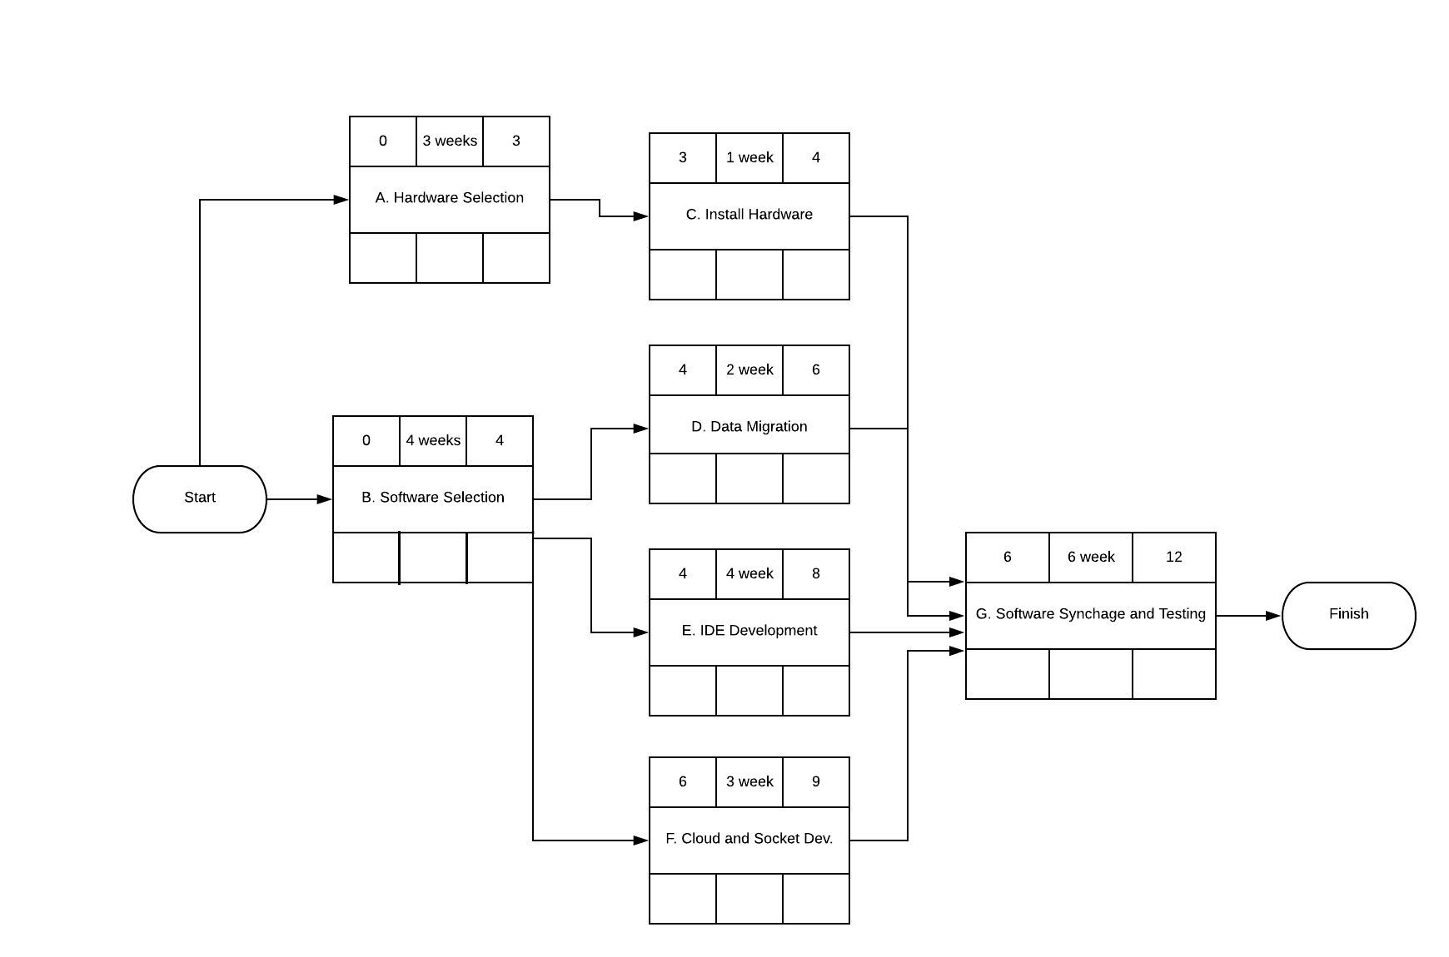

1. **Risks**

Although the use of an iPad application can be extremely efficient in improving the quality of life on a larger scale, such as reducing the number of waiters needed. It may also pose various potential problems that can affect the software in the long run.

Some risks may include:

1. It is necessary that the hardware being used is compatible with the developed software which is why more effort is being allocated to the hardware and software selection activities of this project, that way we have a higher-understanding of which selections provide the most optimal synchronization
2. Any meals ordered by a customer must be stored in the local cloud server and database without fail. In a lot of cases, customers are charged when they order so a loss of a single order can be detrimental. Security and 100% availability of the socket for communication is needed to ensure a more ideal software.
3. Requirements may not be fully defined. For example, as a restaurant adds more items to the menu, the expandability of the storage will need to be considered
4. Maintainability of the application may be a long-term problem. Therefore frequent software updates will be needed.